- Writeup about the workshop

  - Title – Poetry walk with the Elements

  - What happened - All participants went for a walk in the forest. I read aloud a poem by Mary Oliver about how paying Attention precedes all writing, urging everyone to pay attention to nature as they walked silently. Everyone was then asked to pick one natural element that resonated most with them.
That element became their nature name. For the rest of the walk, everyone was asked to observe and pay close attention to the element of their choice. After walking for a while, we stopped at a comfortable place in the forest where we all sat down to write. The brief was to write a few words or sentences about our chosen element – whatever came to mind, without putting it into a structure or framework. The idea was to record first impressions and allow free expression via words.

  - What was the outcome - Once everyone had finished writing, the circle was opened to share what they had written with the group, if comfortable. Almost everyone read out what they had written. They were asked to send their writings to me. I selected a few lines from everyone, that for me, represented the essence of their writing. With some structuring and editing, I compiled all these lines together into a poem titled “Elements”. During the artist showcase, I recited this poem.

  - Relevant photographs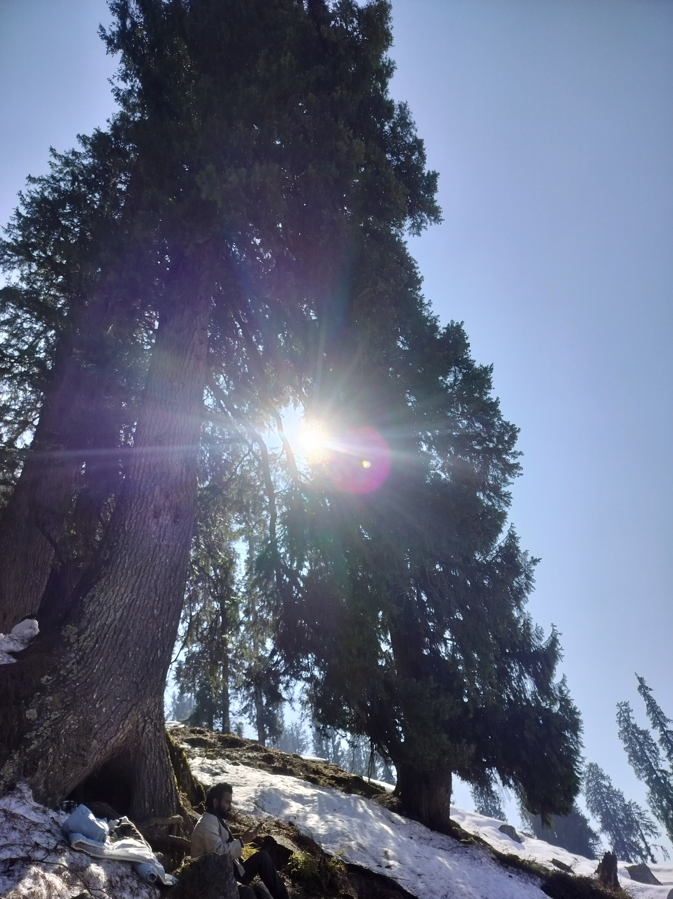
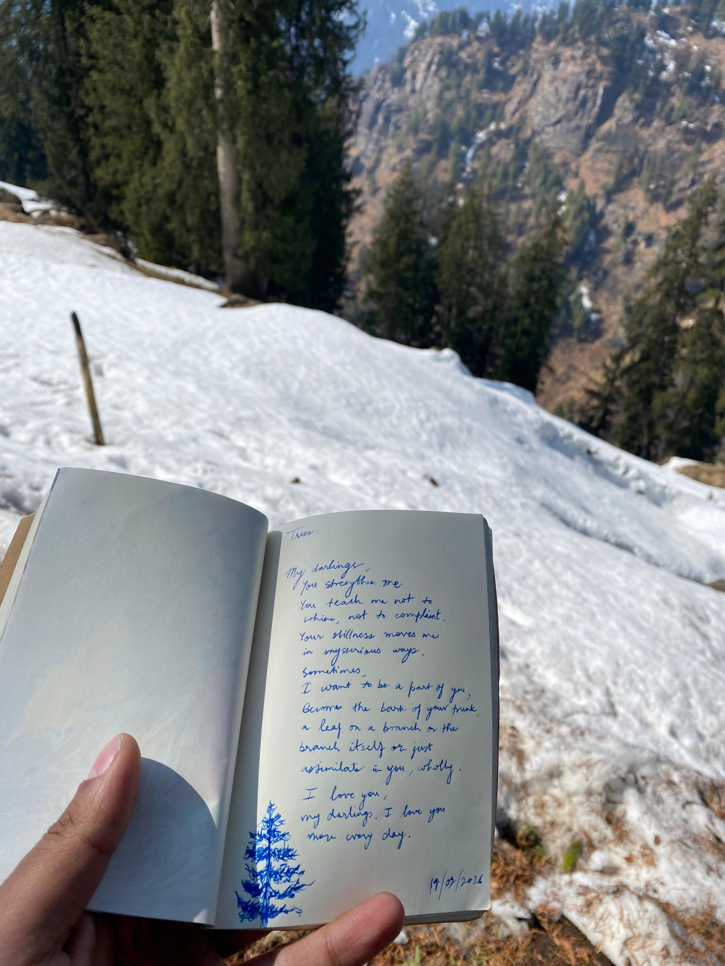
- Writeup about the Artwork and the process

  - Title – 4 poems titled i) Elements ii) Magic iii) Radio Head iv) Secret Places

  - About the artwork (emotional + technical) –

    - Elements – A poem compiled from the outcome of the writing workshop where all participants wrote something about a natural element of their choice. Technically, it was a compilation of what everyone had written, put together in a lose poetic structure. The emotion behind this poem was to have everyone’s words and thoughts together in one place, as a combined offering to the natural elements that move us the most as artists.
    - Magic – This was an incomplete poem that I completed during the residency. It talks about how everything in nature is magical and how transient that magic is. Being in the midst of nature at Glampeco, I was inspired to complete this poem.
    - Radio Head – This was a new poem I wrote during the residency. It’s about the unending chatter in my head and how it prevents me from living in the moment, even when I am surrounded by the beauty of nature. Technically, it’s not complete and I would like to spend more time to polish and complete this poem.
    - Secret Places – This poem emerged from a few stray lines I had scribbled in my diary long ago. Strangely, to me, the residency felt like an escape, one of those secret places that I cherish most. With this thought, I wrote a poem about all the secret places that are dear to me.

  - About the process of creation – The process of creating these poems was a mix of inspiration, reflection and reconnection with old ideas. I was inspired by the other artists and their approach to creation and the raw beauty of the place we were in. Some of the work emerged from inner reflection about my state of mind. Some old ideas resurfaced and held me in their grip until I was able to find release in the form of writing and creating a poem from them.

